
Advanced Information Sheet
ISBN 9781918204018
PRICE £15.00
PUBLICATION DATE 21 May 2026
FORMAT Hardback
ILLUSTRATIONS None
EXTENT 272 pages
CATEGORY Fiction
BIC CATEGORY FB
SIZE (h x w) 198 x 129 mm
7.79 x 5.07 in
RIGHTS WORLD
Author Information
Neil Gunn is the author of more than 20 works of fiction and memoir. He was born in Dunbeath, Caithness and lived, worked, and wrote about life in the Highlands.
Louise Welsh is the author of best-selling, prize-winning novels as well as stage plays and opera libretti. She lives in Glasgow, Scotland.
Blood Hunt
Neil M Gunn
Introduction by Louise Welsh

This tense, psychically aware thriller hooks the reader from the first page when a local policeman arrives at the home of an isolated crofter in search of a young fugitive.
Blood Hunt is a tale of, love, murder, divided loyalties and the awful human instinct to hunt a fellow animal down - even to death.

From the moment Sandy opens his door we enter into the ancient world of crime and punishment, action and retribution, of passion and the centrality of a woman’s power, brought bang up to date by a precise, psychologically acute narrative of the killed and the killer.

Who is right? Who is wrong? What is the story behind this tale of terror and revenge? Blood Hunt plots these questions and more, as, step by step, it takes the reader across a wild and remote landscape that is the stuff of myth and fable.

Gunn is a major Scottish writer with an international reputation; this beautiful new edition aims to re-establish him as a central figure in Scottish letters.

- Handsome hardcover with embossed linen cover and stunning printed endpapers
- Major PR campaign celebrating the relaunch of Gunn’s major works
- Newly commissioned introduction by Louise Welsh, author of numerous, best-selling and prize-winning fiction.

One of the most important Scottish writers of the twentieth century ― TLS

Modern Scottish fiction reaches its highest peak in the novels of Neil M. Gunn... Like Hardy, and indeed Joyce... he transcends regionalism and acquires universality. ― The Scotsman

Neil Gunn has given us a wonderful body of work…the greatest achievement of its kind in modern Scottish literature ― Hugh MacDiarmid

A brilliant novelist – Lewis Grassic Gibbon

Related Titles
The Grey Coast HB ISBN 9781918204001
The Serpent HB ISBN 9781918204025

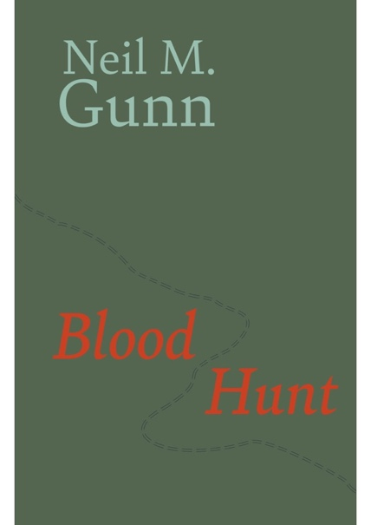

North House Press, The Grey House, Dalreavoch, IV28 3YF Telephone +44 (0)7768994332, Email: david@northhousepress.co.uk www. northhousepress.com

